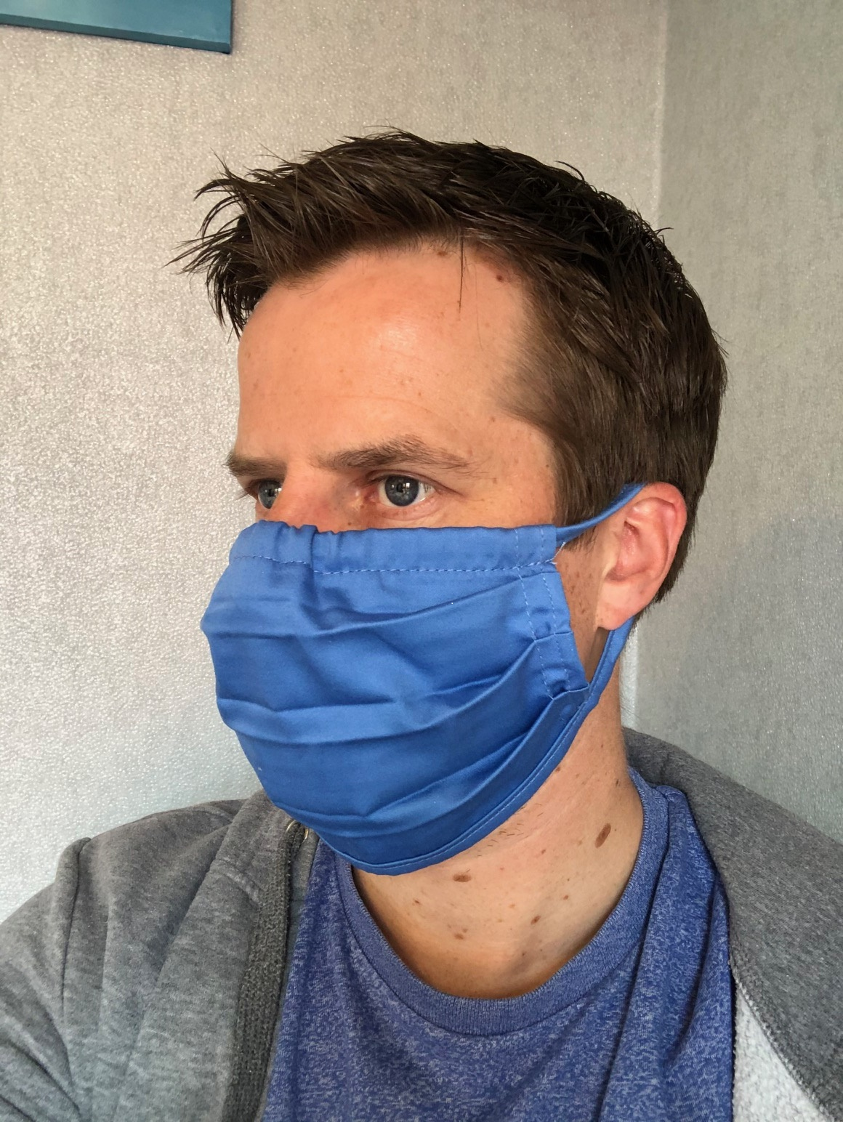

Training Form

Face Cover

- The company shall provide face covers for operators where the job risk assessment identifies a need.
- Face Covers must be worn for the jobs and work areas that have been identified
- The Face Cover must be fit for purpose and in good condition to provide the required protection
- Each operative will receive 3 Reusable Face Masks to wear if they wish whilst carrying out their daily duties
- The Face Cover must be stored safely to ensure that they are not damaged or contaminated.
- They should be routinely washed depending on the frequency of use.
- Face Cover must only be worn by the individual it has been issued to.
- Individuals should be careful not to touch their eyes, nose, and mouth when removing their Face Masks and wash hands immediately after removing.

I have received the face cover, read and understood the instructions that I have been given and sign to state that I shall comply with these instructions.

PRINT NAME
SIGNATURE
DATE
PRINT NAME OF TRAINER

It is the responsibility of the wearer to ensure your Face Cover is checked and fit for purpose

